The Business of Comics
Economists long for those perfect case studies that work so well in illustrating an abstract point of economic theory by presenting a real-world example full of human drama and marketplace interactions. And while it is still too early to tell whether the latest news from the comic book industry will become a featured story in econ textbooks years from now it certainly has all the fixings.
The news centers on an interesting development that just reared its ugly head in that microcosm of the entertainment world that produces the majority of the world’s comic books (or sequential art for the more refined): after a 25-year exclusive relationship, DC Comics has decided, to part ways with Diamond Comic Distributors.
To understand the ramifications involved a history of how comic books are sent to the market is in order.
For much of their history in the United States, comic books were considered as just another periodical and the primary method they were sold to the end consumer was through the newsstand. The newsstand owner negotiated quantities with the publisher and distributor months in advance. He displayed the books for a time and split the revenue with the partners. Since the units were provided on consignment, any unsold copies were then returned to the publisher (usually, to save shipping, the covers were returned with the proviso that the newsstand destroy the interiors).
Marvel Comics began to explore the concept of a direct market for comics in the late 1970s under the direction of Jim Shooter. The primary innovation was that the comic books were sold to a store well below cover price and the store would subsequently sell the product at cover price netting, as revenue, the price differential. Since the store owned the product outright, any unsold units remained in its possession. The genesis of the direct market is marked in late 1980 with Dazzler #1 being the first regular, monthly comic being sold exclusively in the direct market.
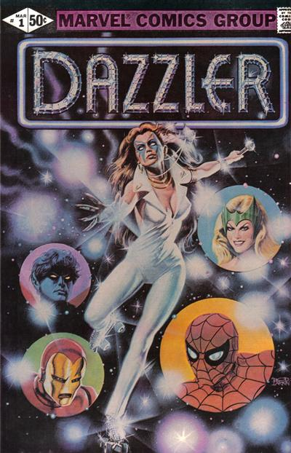

The store generated a greater profit per unit than at the newsstand but it also ran the risk of buying a product no one wanted that languished on the shelf. Comics publishers also helped to mitigate the risk by publishing stories with large crossover events that linked poorer-selling titles to better-selling ones and by writing stories that spawned interest in back-issue purchases. The consumer enjoyed the advantage of being able to sample the book before purchase but at the cost of paying the markup.
This approach put a premium on distribution. After some settling-in time, there emerged three companies that handled the majority of comic book distribution: Capital City, Diamond, and Heroes World. Riding high on the comics boom of the early 90s, Marvel Comics bought Heroes World Distribution in 1995 to exclusively distribute their product. Diamond responded with exclusive deals with Darkhorse, Image, and Archie Comics and Marvel’s main rival DC Comics. Left out of the main action, Capital City soon after sold out to Diamond. An overextended Marvel then filed for bankruptcy protection in 1996, effectively ending Heroes World Distribution in 1997 and leaving Diamond as the only game in town. Comic Tropes’s video How Distribution has Saved and is Now Killing Comics gives a comprehensive summary of this history, including some details about the anti-trust litigation not discussed here.
It’s hard to tell what impact this monopoly has had on comics over the years. Sales figures of US comics to the direct market show a growth from about $15 M to $27 M in the twenty years since (taken from Comichron’s sales summaries), which amounts to a about 15% growth, after inflation. Spending on general entertainment was closer to 30% over a similar timespan but comics has to contend with the emergence of a host of substitutes including manga, anime, and videogames. Comic book publishers resorted to an ever-increasing array of gimmicks to try to lure more customers in (rebooting of a series or a whole universe, tie-ins with movies, changing the lead character, etc.) but often stores were stuck with hundreds of back-issues will no way to unload them. Susana Polo’s video, The BEST WAY To Buy Comics!, presents some of the ways in which the direct market distorts comic book creativity.
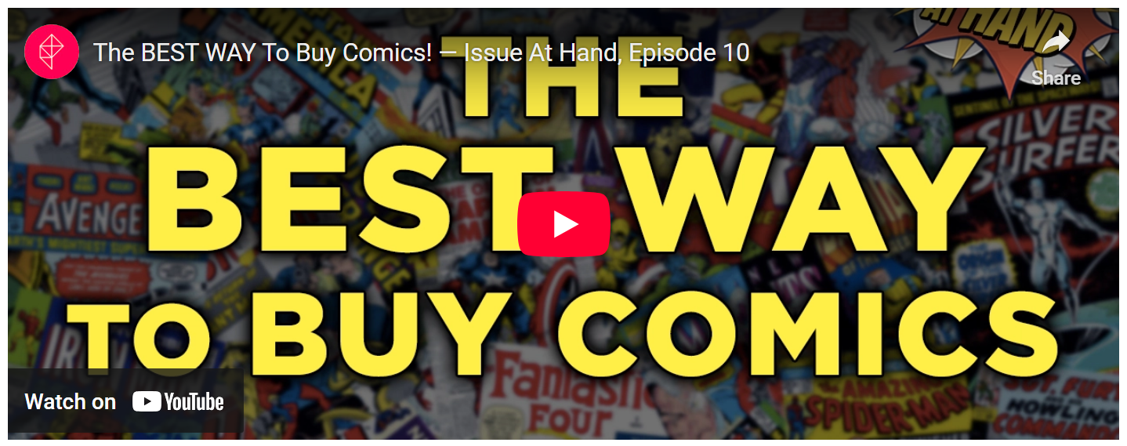
<iframe width="560" height="315" src="https://www.youtube.com/embed/94FsJcYW0Uc" frameborder="0" allow="accelerometer; autoplay; encrypted-media; gyroscope; picture-in-picture" allowfullscreen></iframe>
This delicate balance continued for over 20 years until recently when DC Comics broke from the fold and interesting question is why?
According to Peter David, a long-time comic book creator who got his start in sales at Marvel, this move is DC’s way of declaring war on its long-time rival.
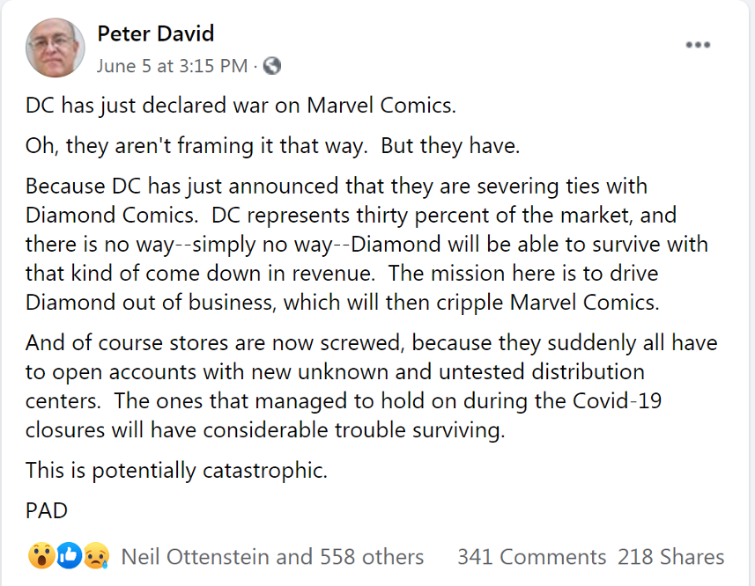
One can certainly understand David’s interpretation given the fact that DC makes up about 30% of the total US comics market share ($8-9 M versus $11-12 M for Marvel and $28-32 M overall in 2017), but before concluding he’s correct let’s explore economics of the situation a bit deeper.
First, the basic facts about the new arrangement. DC is going with three distributors instead of one: UCS Comic Distributors will handle the east-coast, Lunar Distribution will handle stores in the west, and Penguin books will provide graphic novels and collections (not monthly comics) to US bookstores. In the Bleeding Cool article Stagnant DC Sales, Diamond Plans and What Happens Next – The Gossip, author Rich Johnson points out while Diamond has a transportation hub (Diamond UK) in England that enables them to service the European market with US comics in a cost-effective way neither UCS nor Lunar does. One of the UK stores mentioned in the piece says that they now have to purchase comics at above cover price due to the high cost of shipping and Johnson also notes that even though the UK makes up 10-15% of Diamonds overall distribution, DC owns the lion share of that slice.
Second, some feedback from DC is in order. In his article DC Comics Admits Comics Have “Sustained Stagnant Growth” In Decision To Cut Ties With Diamond Comics Distributors in Bounding Into Comics, John F. Trent covers the email that AT&T-owned DC Comics sent to retailers on June 5, 2020 in which they admitted that “sustained stagnant market growth” figured into their decision to part with Diamond Comics Distributors. The article cites an interview with Mark Gallo, the owner of Past Present Future Comics. Gallo’s said that
“[t]his new entity won’t have any incentive to provide terms in my opinion. I personally have 28 day terms with Diamond and I’m assuming I’ll be cash on delivery with this new distributor. This looks really bleak.”
Gallo also added that
“blaming a distributor instead of their unsellable woke trash product. Total deflection. Comics fans want good stories and art not a laundry list of woke writers interjecting their politics into character development and storylines.”
Johnson believes the gossip on the street supports Gallo’s view that the product itself bears blame. Johnson notes that Pamela Lifford, President of Warner Bros. Consumer Products has no love for DC Comics and that she views them as costing too much to make (production, labor, and time) and would rather have DC focus on their graphics novel line and bookstore market.
We are now in possession to better understand the possible reasons DC split from Diamond and to judge Peter David’s assertion that this is a declaration of war by DC on Marvel.
- Suppose, for the sake of argument, that DC does drive Diamond out of business. Wouldn’t either UCS or Lunar decide to take on the displaced companies (Marvel, Image, Dark Horse, IDW, Boom, and so on). They would be fools not to grow their business regardless of how disgruntled DC might be. Also Marvel Comics might be logically viewed as the development arm for the movie juggernaut that is the MCU so it is unlikely that it would be allowed to go under. We conclude that it is highly unlikely that this move represents war on Marvel.
- Perhaps then it is a war on Diamond. This interpretation also seems thin as DC is directly cutting off its nose to spite its face with regards to its UK market. If DC’s comics are going to increase in price overseas there will be a downward push on demand and Marvel and the others may fill the void. Also, unless Lunar and UCS offer even lower prices, there is a distinct possibility that shops will lower the demand on DC as well. Given that the company has not managed to grow their comics revenue and their attempts at a movie universe to compete with the MCU has been far from successful it is distinctly possible that Diamond will be able to reestablish the lost DC revenue as other publishers increase their market share.
- So, it seems that the only likely conclusion is the one hinted at in Johnson’s article: DC executives want to lower cost in the unit and they don’t care if the market share goes with it. Since sales are stagnant the only ways to increase profitability are to either cut product or cut operating costs. In going with their new distributors DC must be achieving a major savings in order to justify the risks involved. If the line of DC Comics fails, they can always say they tried and then they can live for years off of the graphic novels and collected stories while they rebuild a better and cheaper workforce.
No matter what interpretation one finds fits the facts best, there is no doubt it will be an interesting ride.

